* 5560803 SD Portal S SD Portal - Ensure user is able to update Maintenance (PSS).

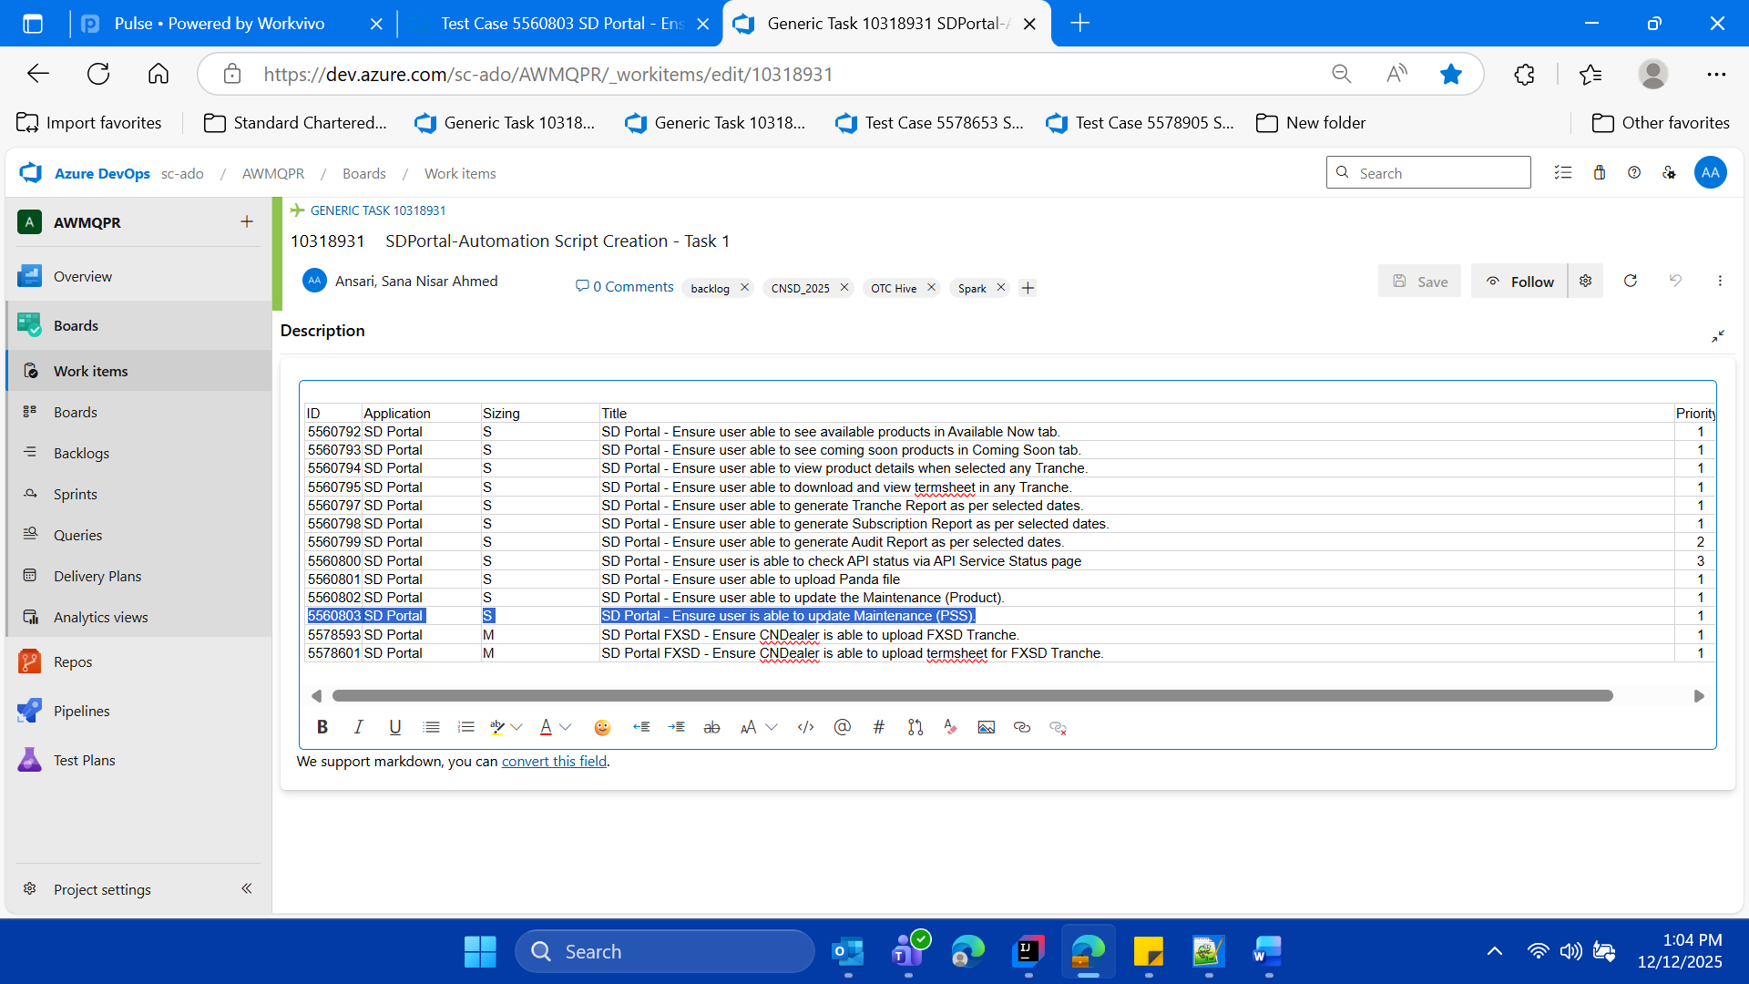

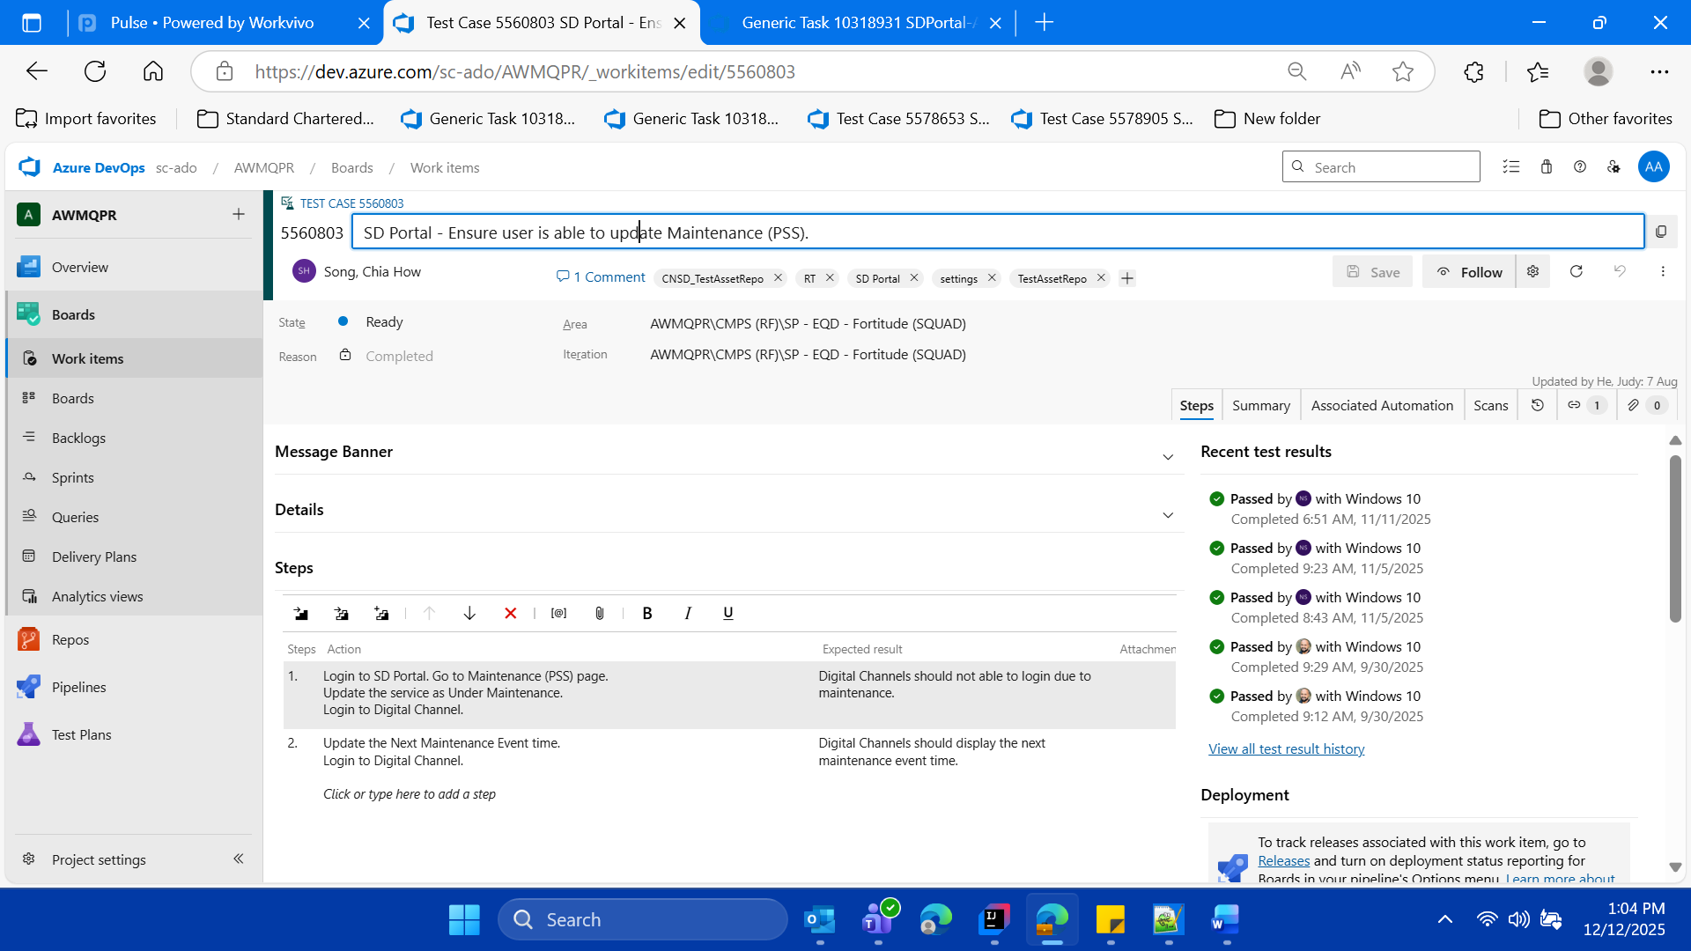



SDPortal New Dev URL

https://cnlvadeqc001.cn.standardchartered.com:8463/wm/full/cnsd/index2.html#/rmp/login

User ID-User Role For Maintenance (PSS) page update

For Maintainace (PSS)

1377543

Password (with LDAP)

SCBpassword5$

**==== For Maintainace (PSS) ====**

Launch URL via already available background SD Portal (as per the login test case which is already implemented within the CNSD FW, so reuse but use this new id 1377543)

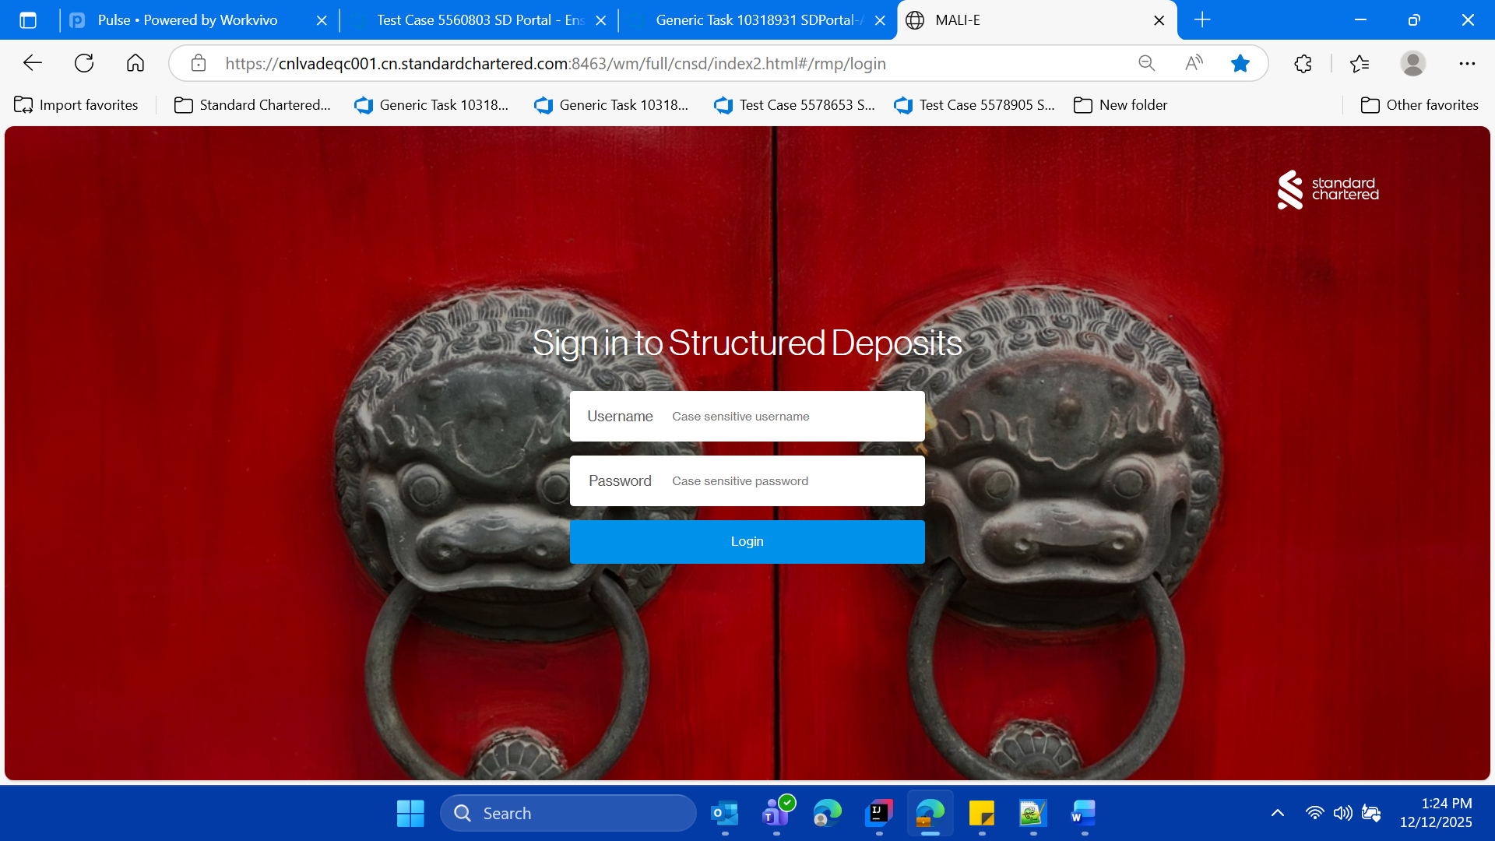

**login in SD Portal with User id** 1377543

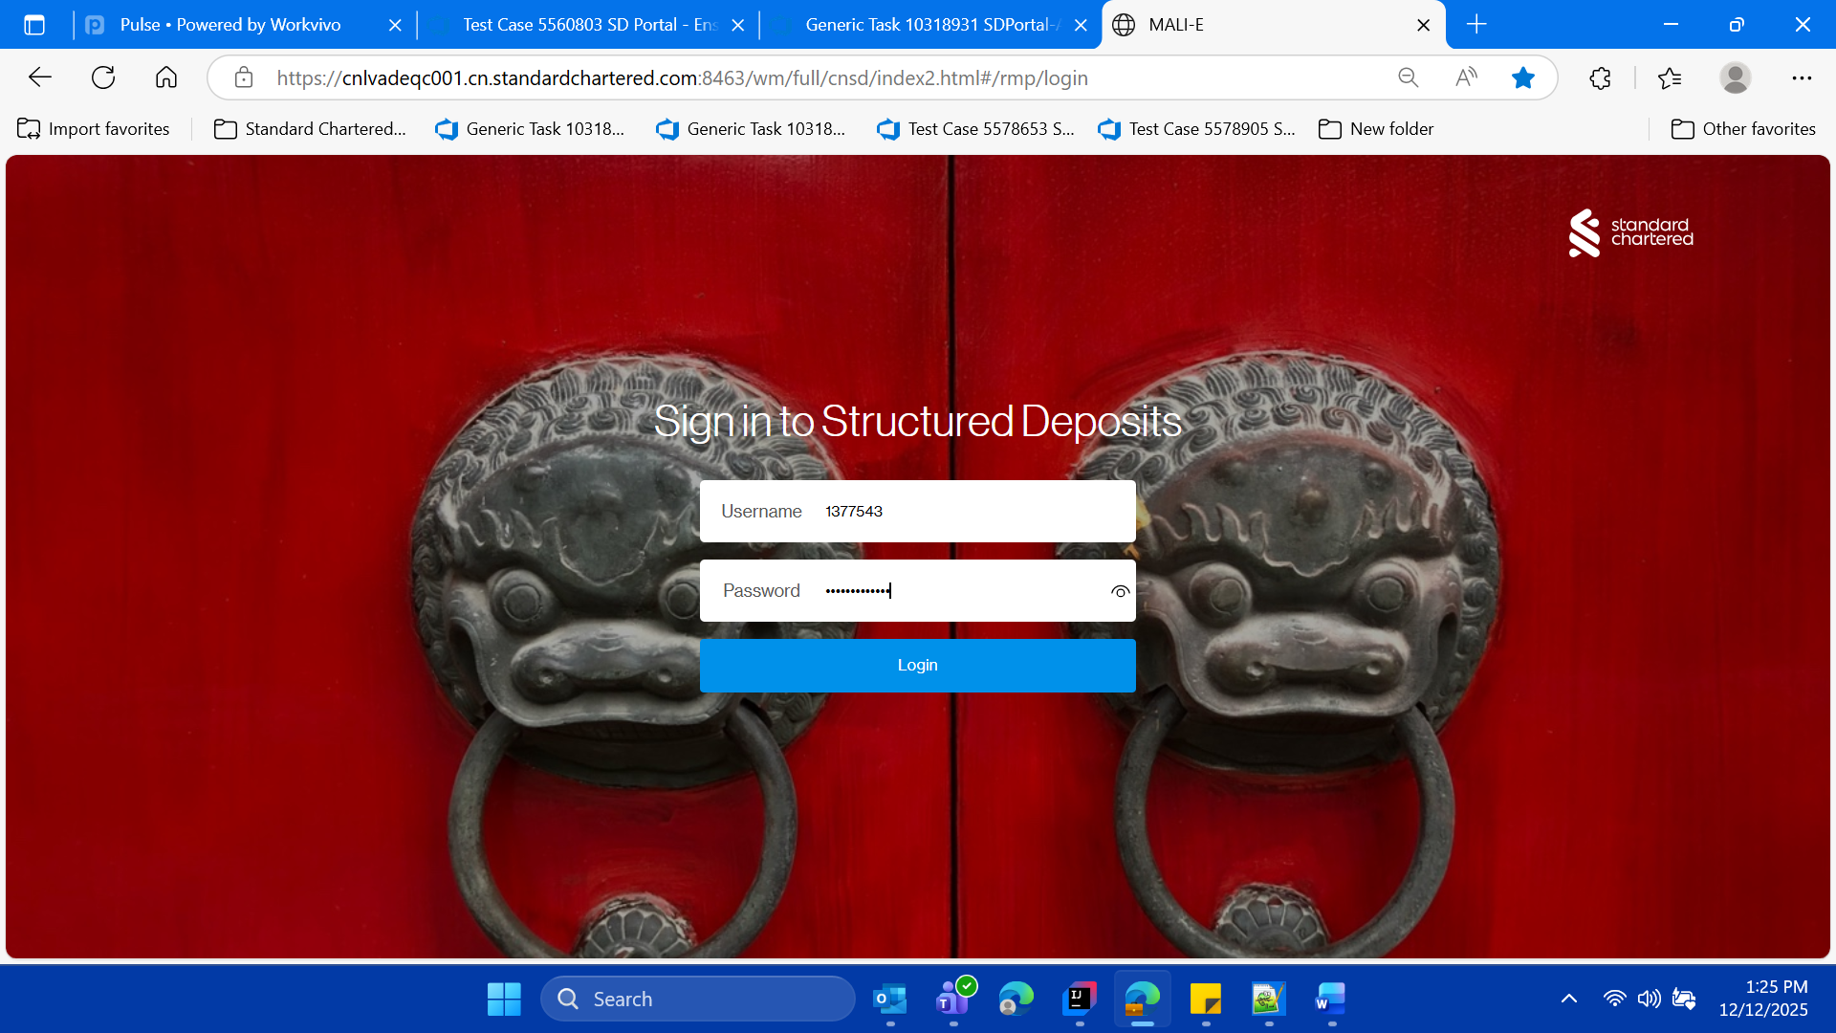

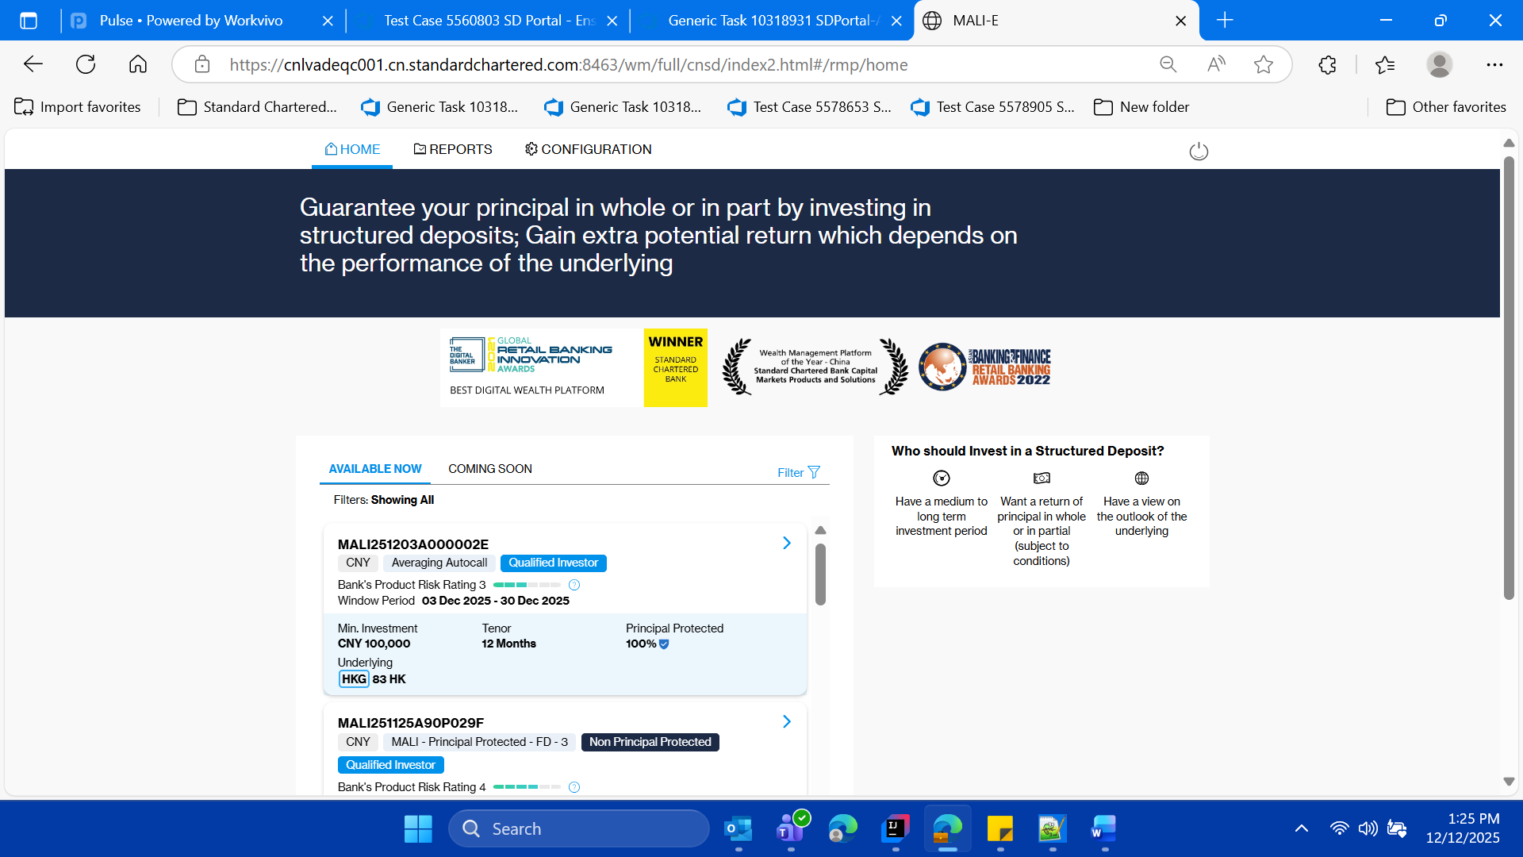

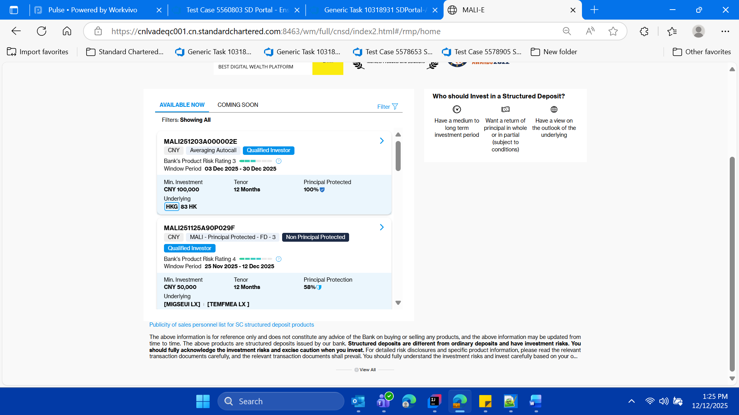

* **Click on the Configuration Tab/ and navigate to configuration page**

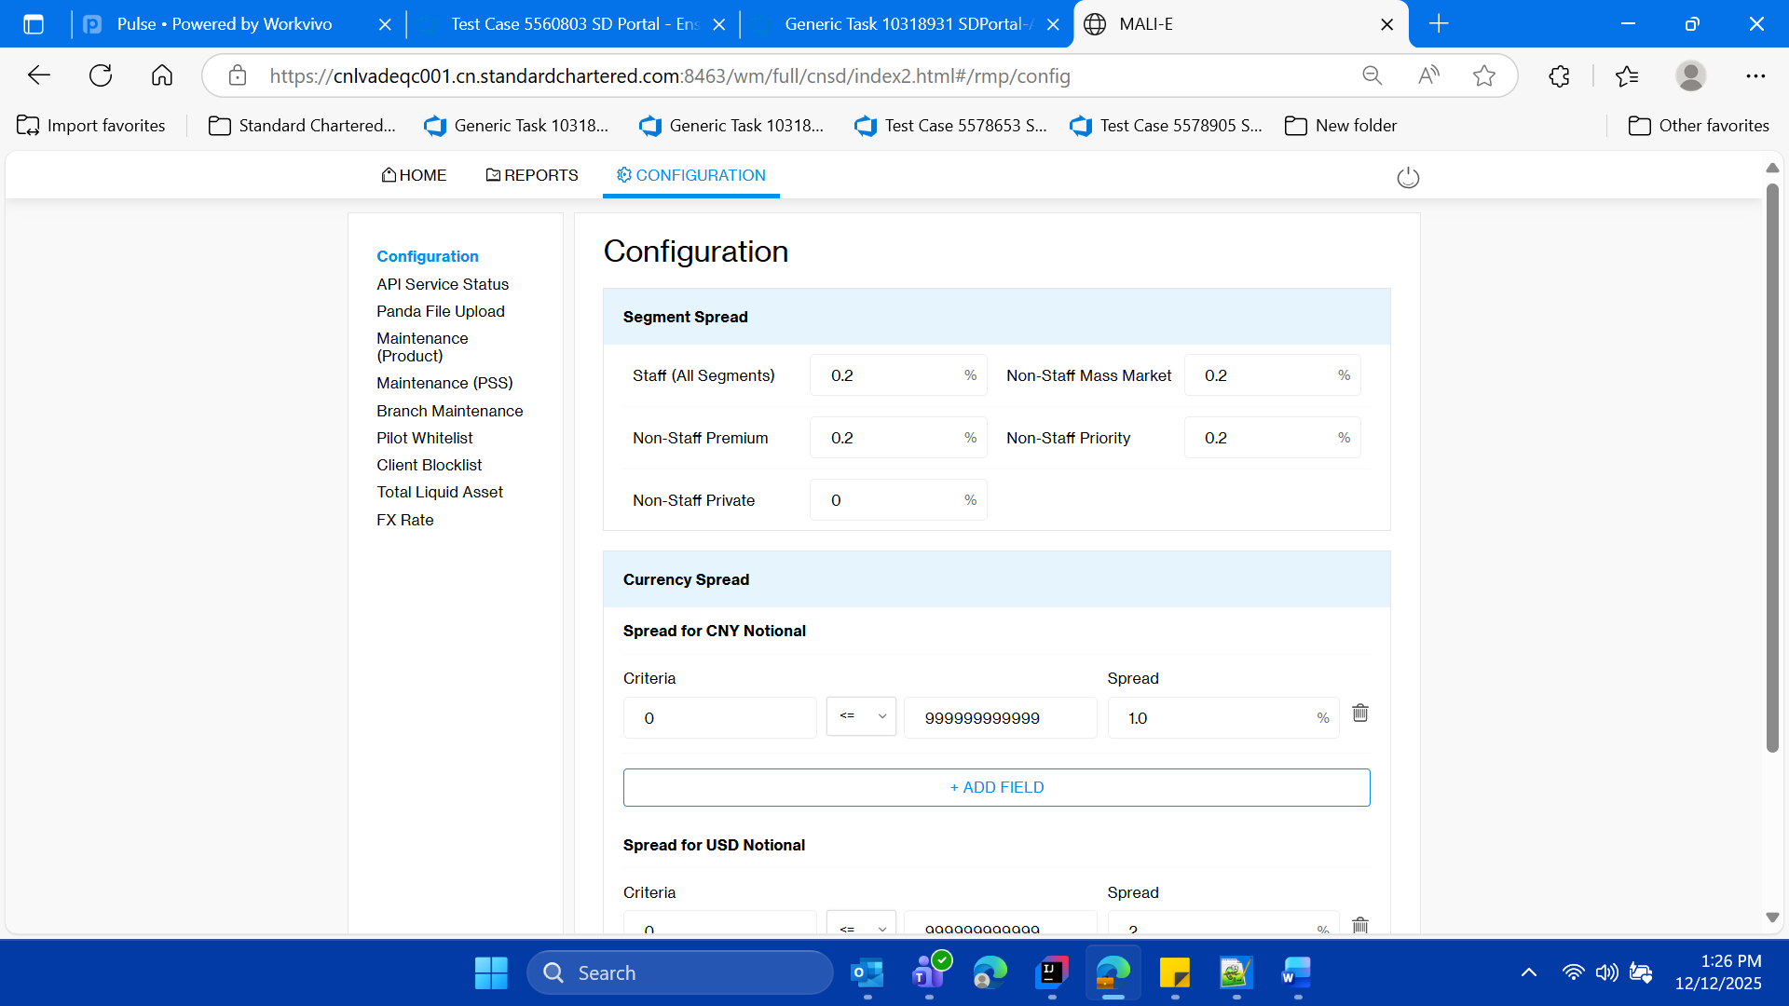

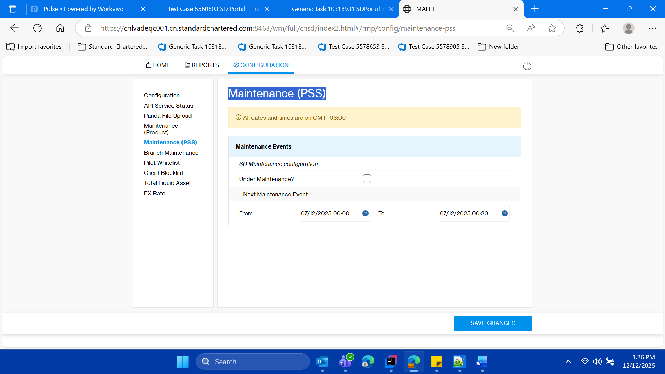

* **Click on the “Maintenance (PSS)” left menu and validate the tilte of the page as “Maintenance (Product)”**



* **Within this “Maintenance Events” section of the page, keep the note of “From Date” and “TO Date” for current day of test case execution**

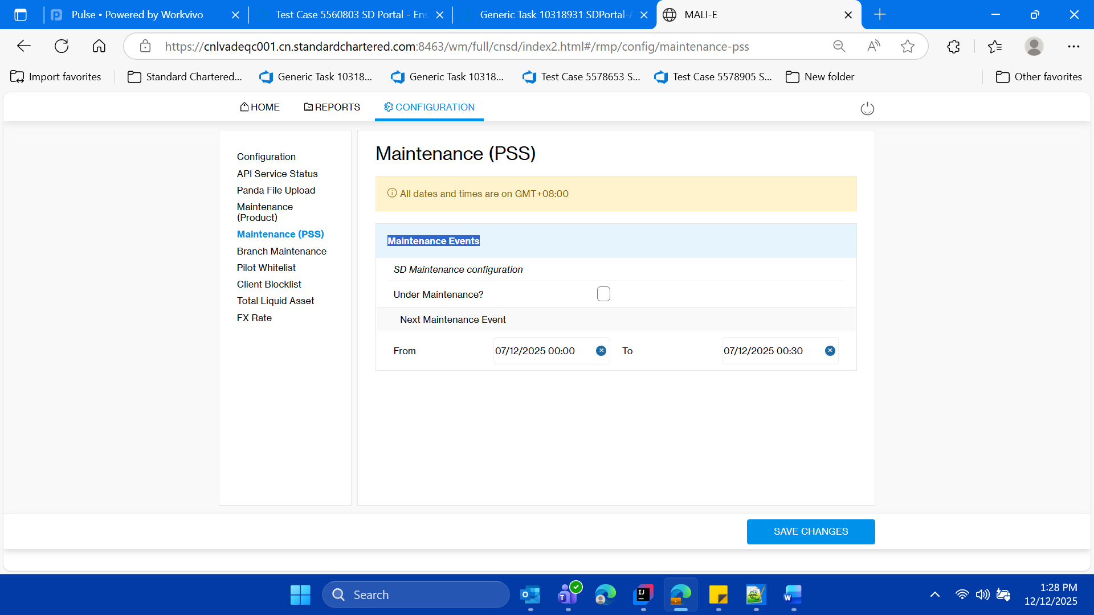

* **Now Update the service as Under Maintenance, by clicking on the check box.**

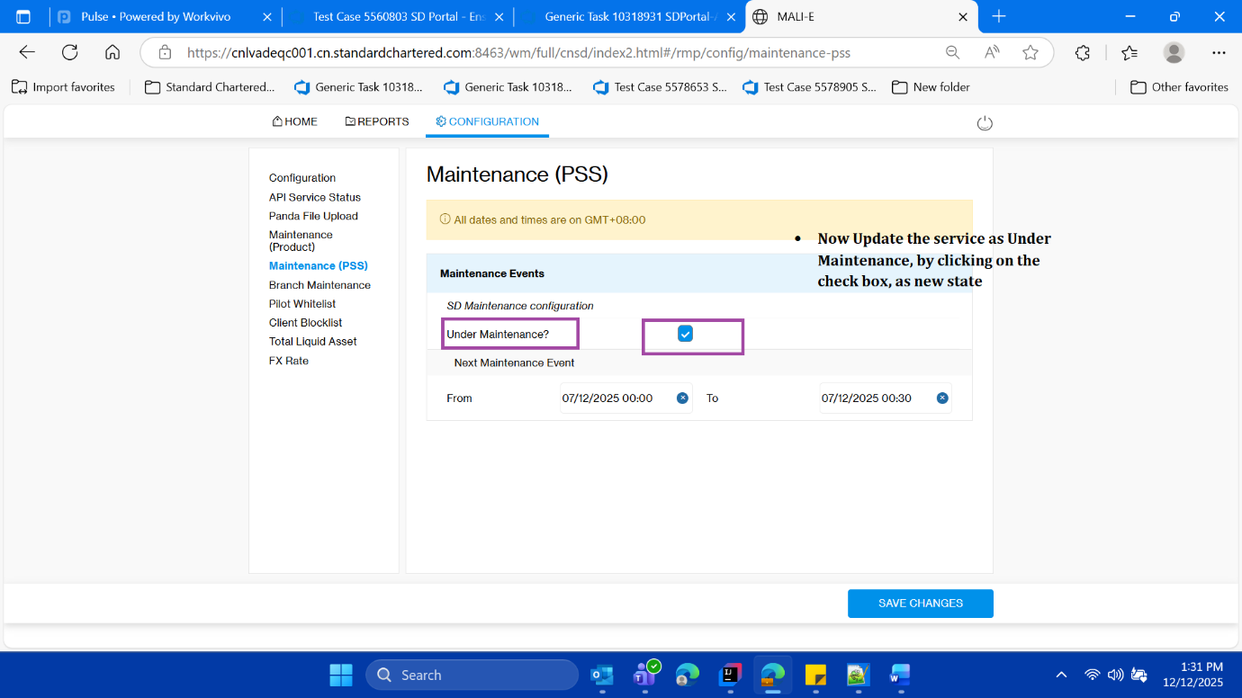

* **Click on save changes validate the success message**

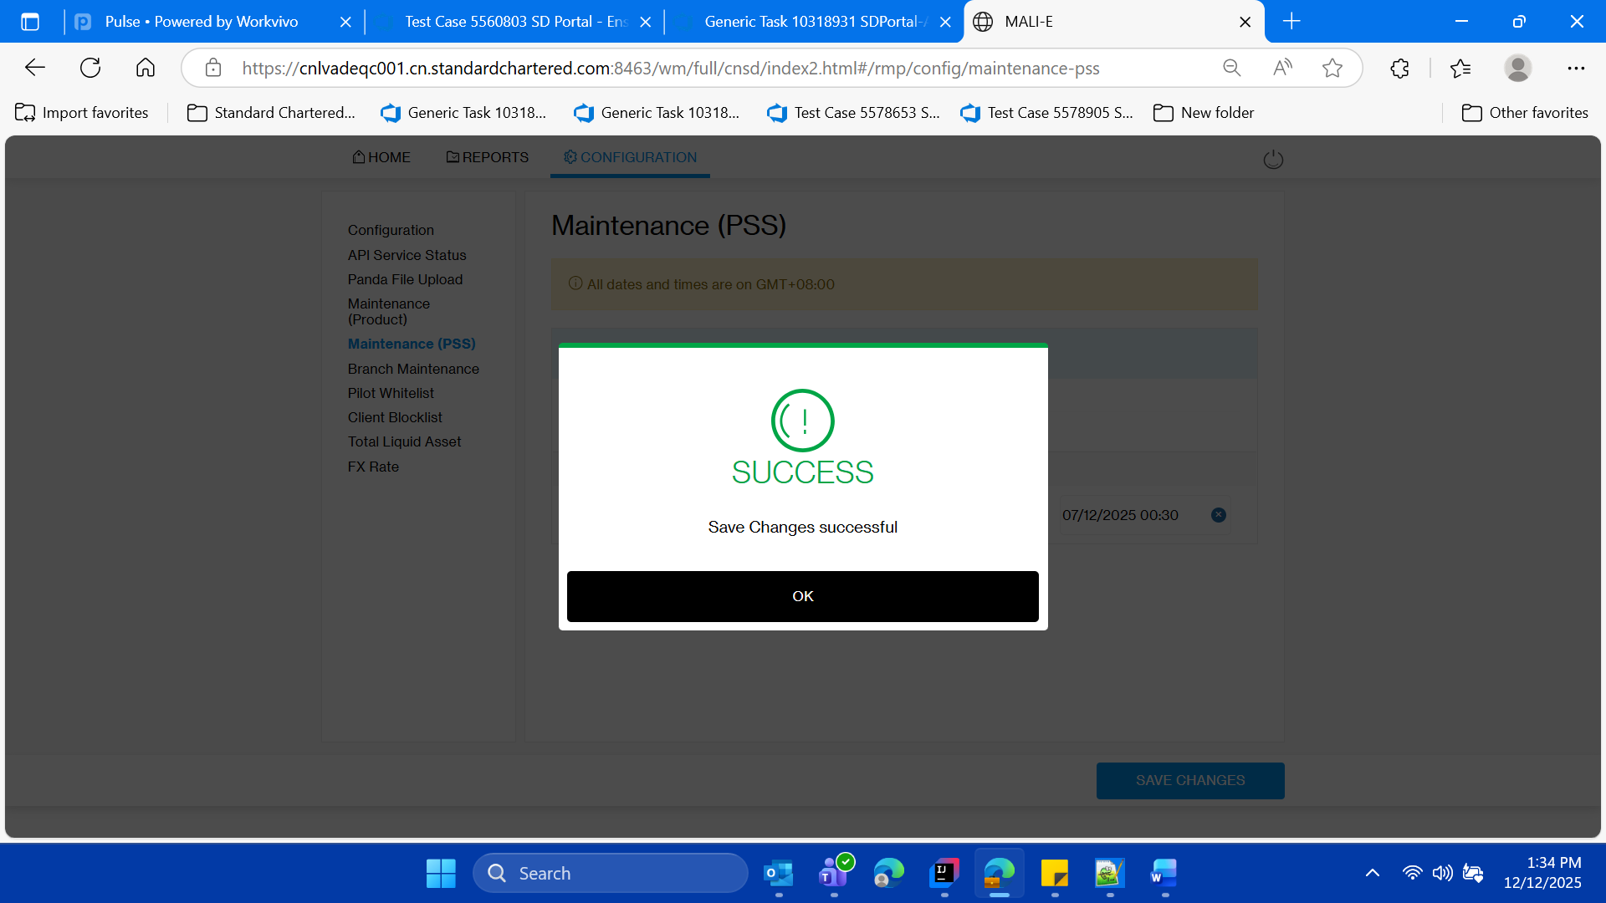

* **Click on ok button on save success message.**
* **Click on OK button**



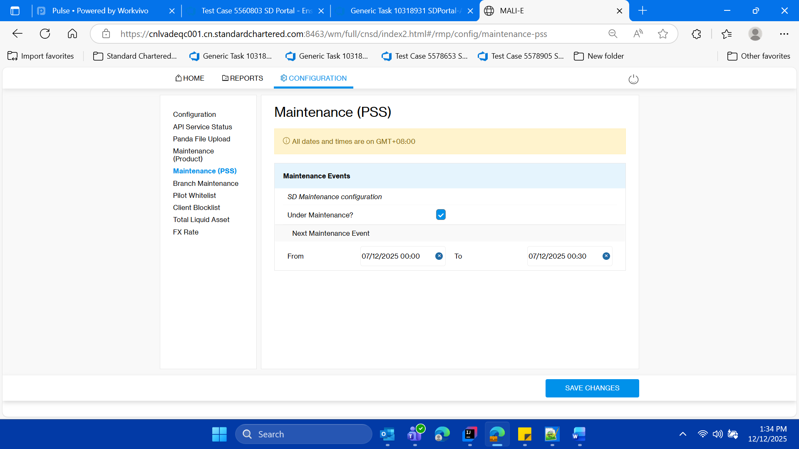

* **Validate the saved Check box”** **Under Maintenance?**

**” is checked**

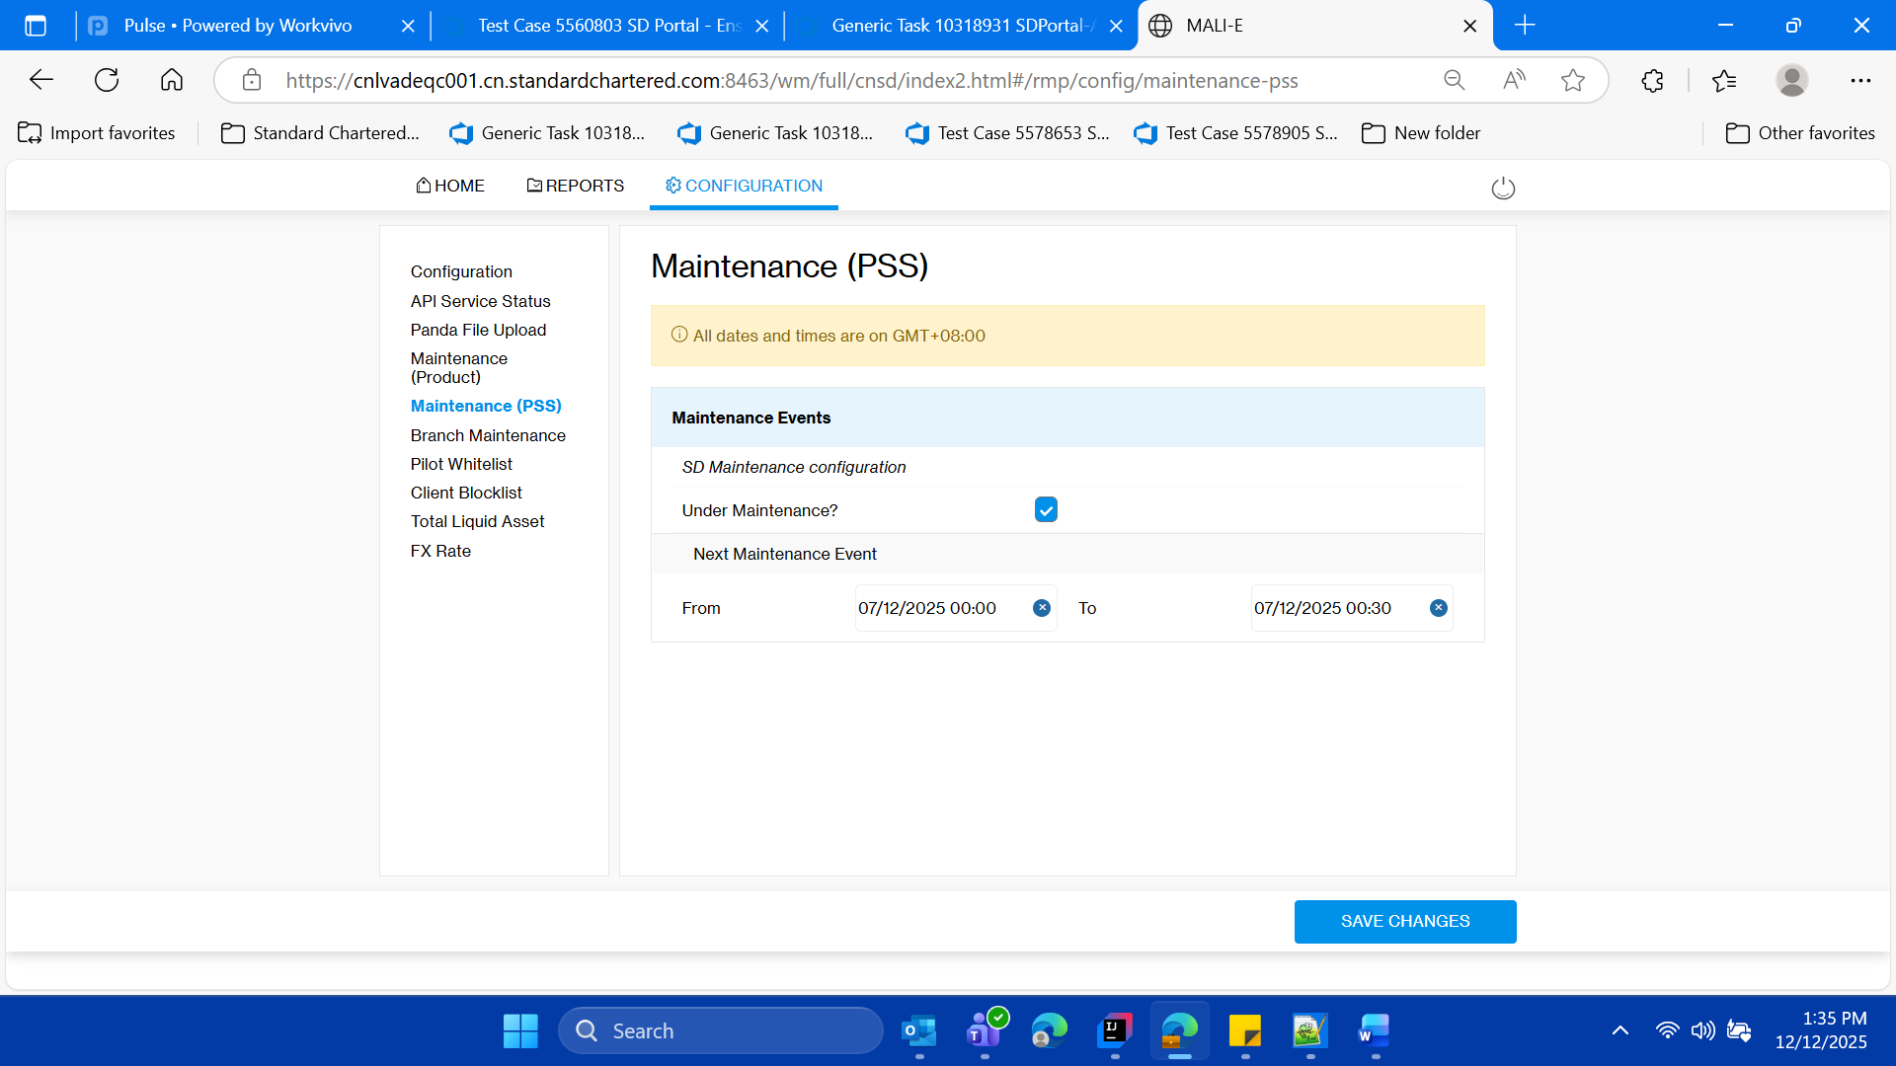

* **Login to SSO MOCK using Client id as 360297291**

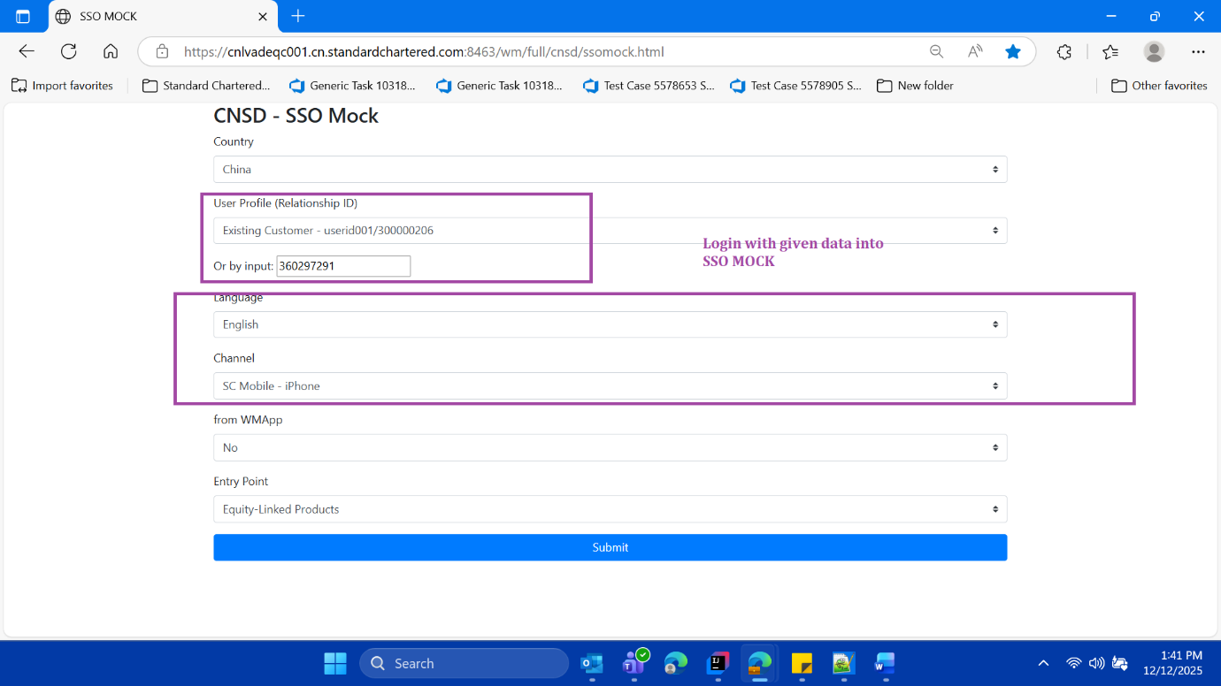

* **Click o submit button**



* **User should not able to login due to under maintenance check box is checked on page CONFIGURATION>>“Maintenance (PSS)” of SD PORTAL” on SSO MOCK home page**

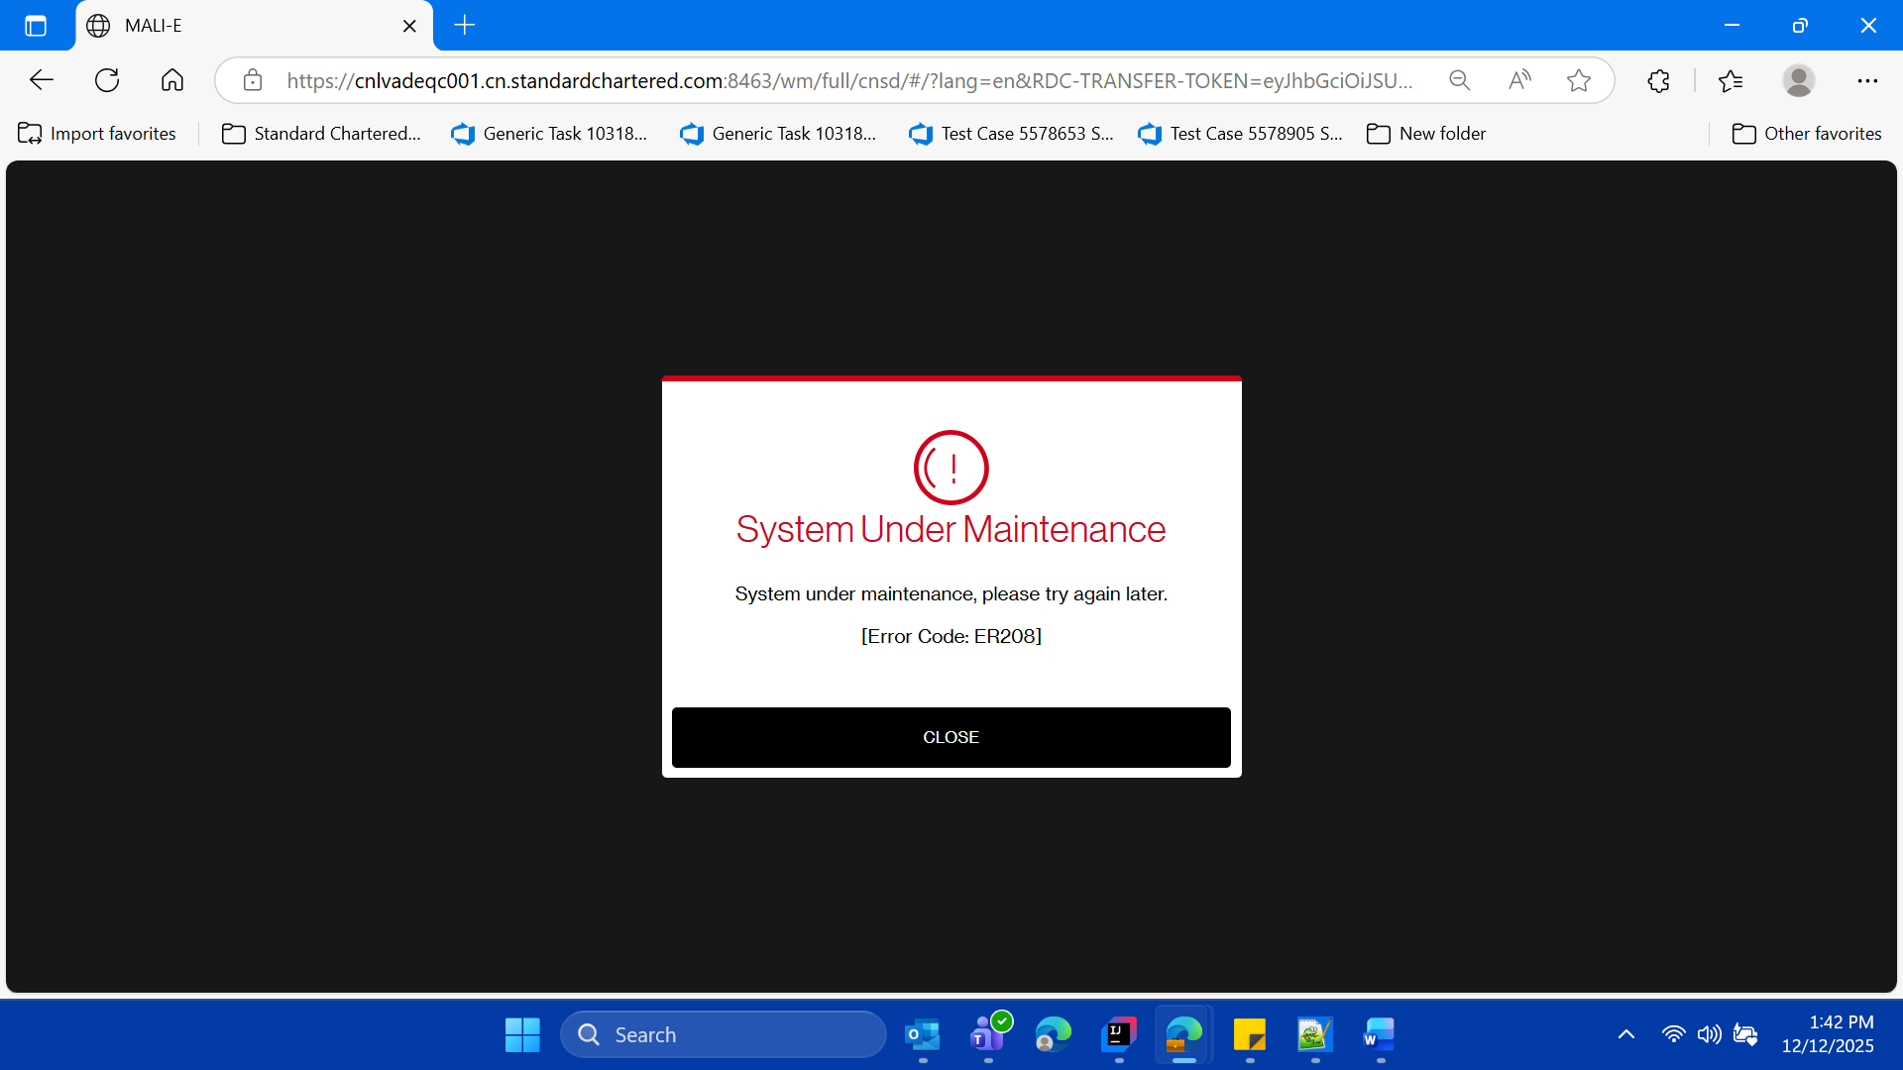

* **Validate the pop up with text on it**



* **Now Click on the close button to close the pop up on in SSO mOck, validate user lands page of SSO MOCK**

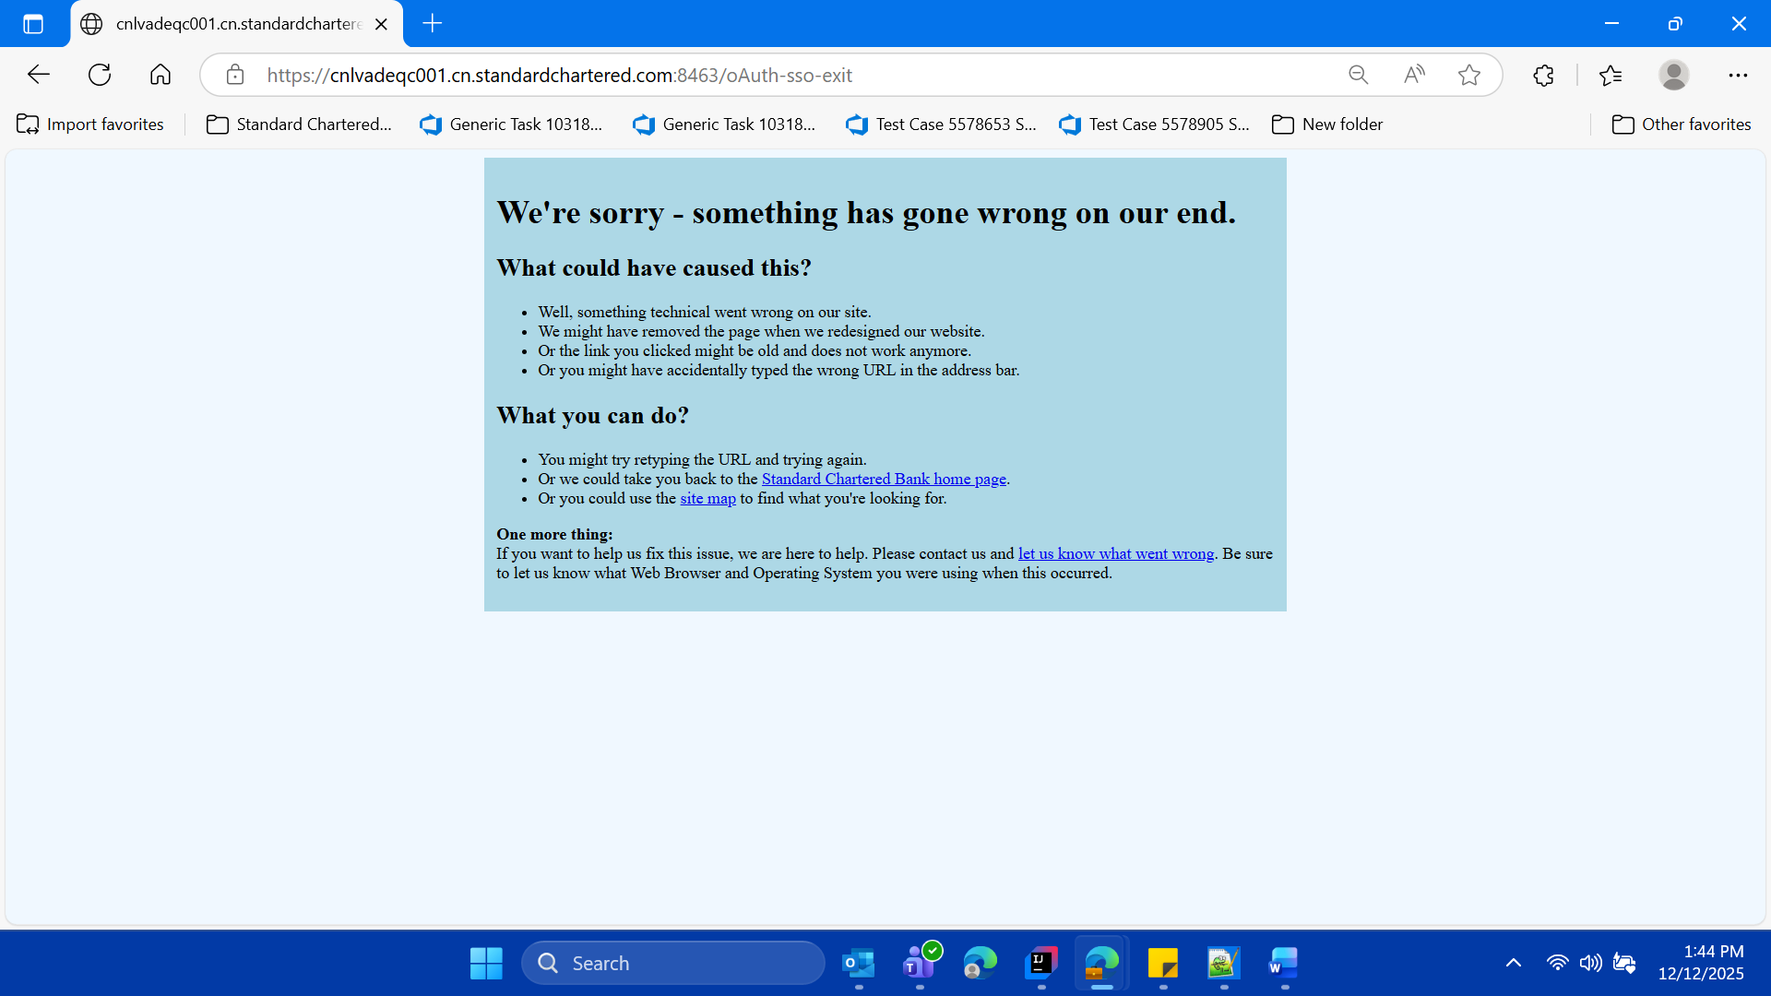

* **Now close this window**

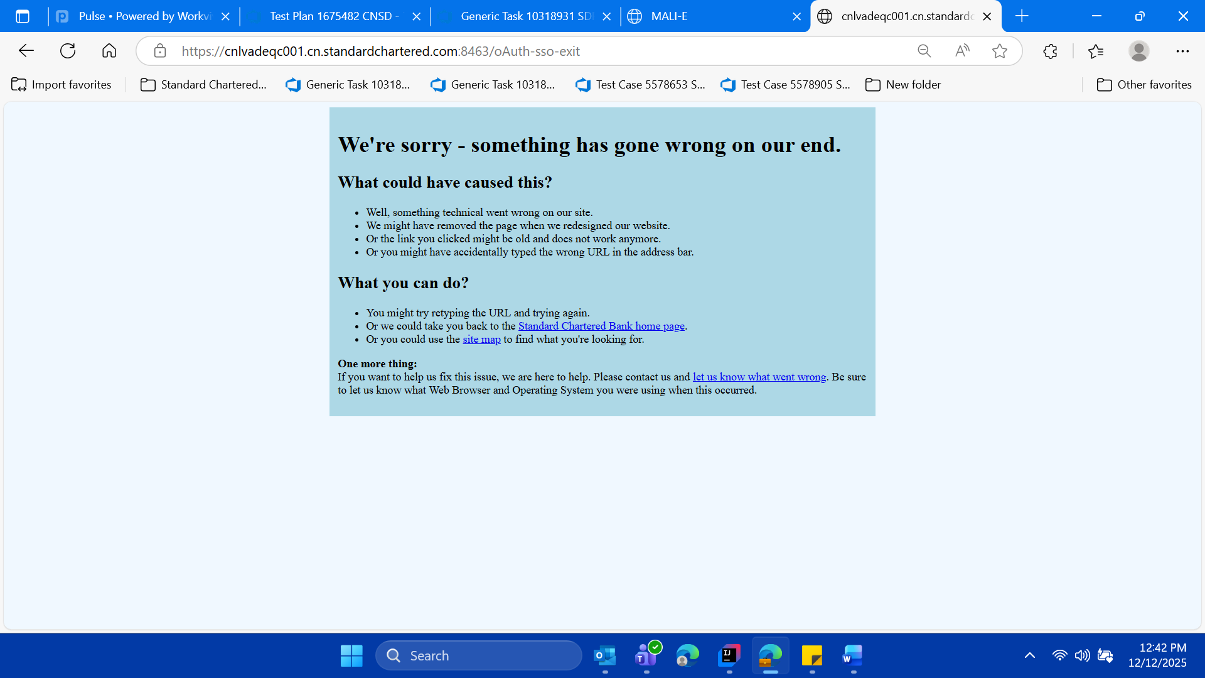

* **Now switch back on the SD Portal parent window , or login freshly into sd portal**

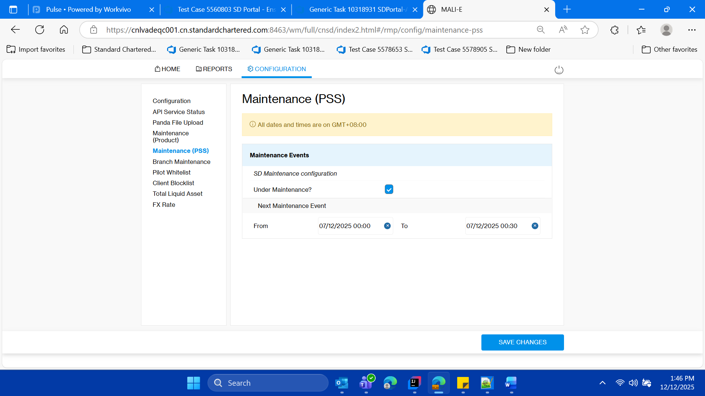

* **Uncheck the check box “ Under Maintenance?**

**” in the format , it was there previously before the execution of this test case for tailor section**

**-So basically converting the application the default state**

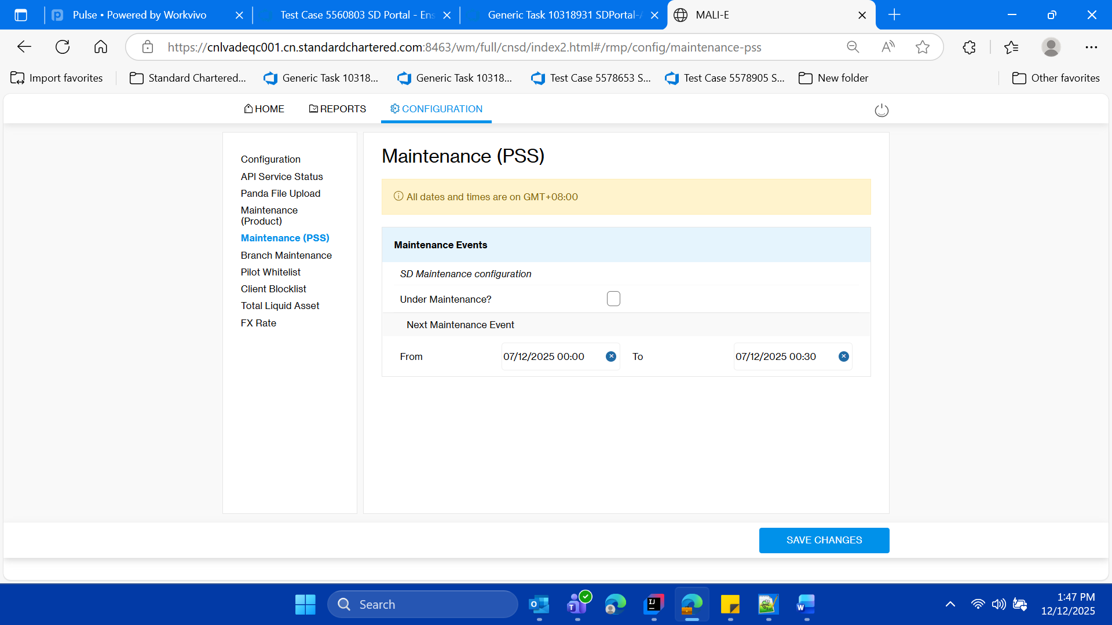

**Vliadate success message**

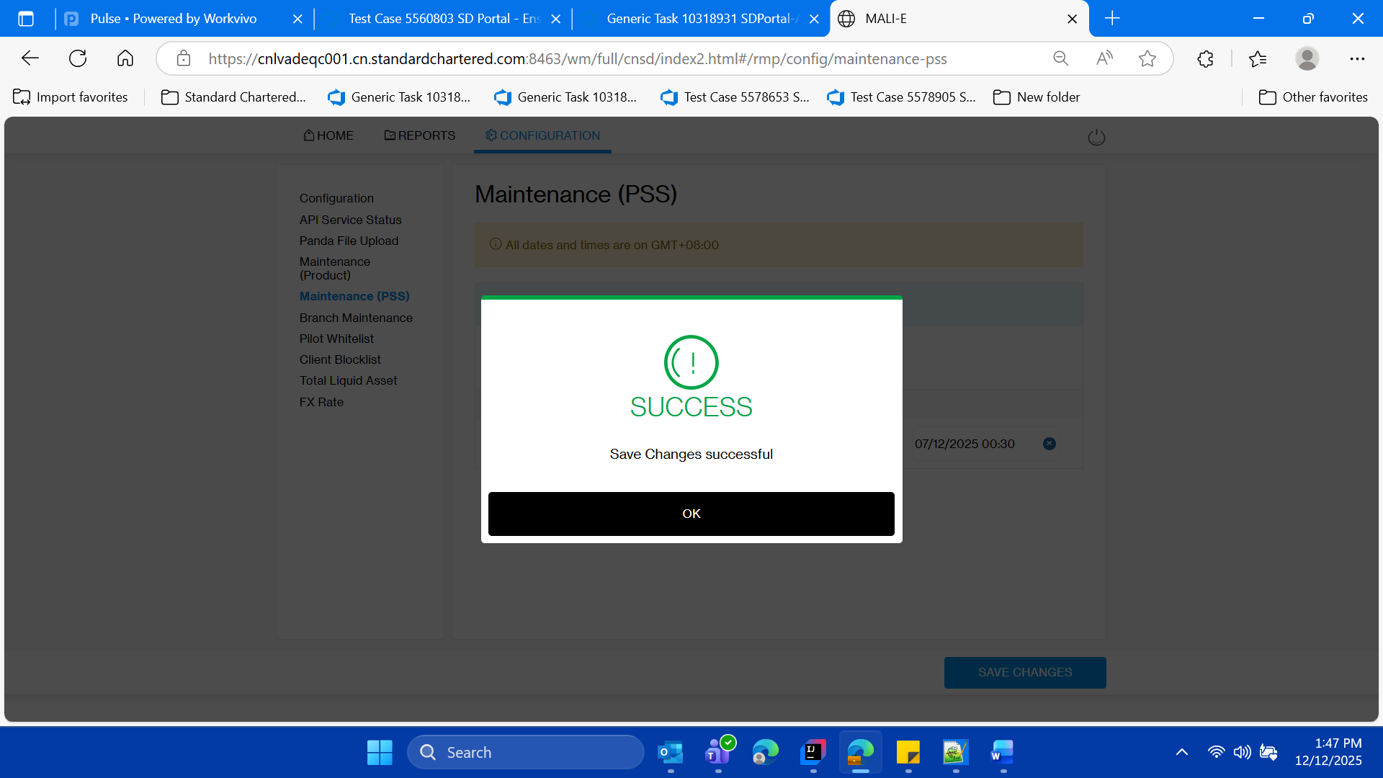

* **Click on ok button**



**Validate the check box is unchecked**



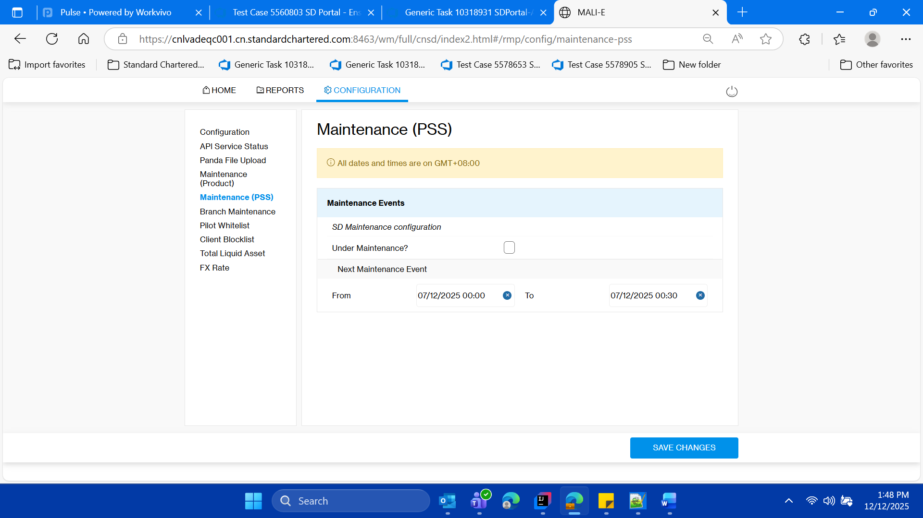

* **Validate the client with client id as 360297291, is able to login into SSO MOCK, as per the default state check of the application..**

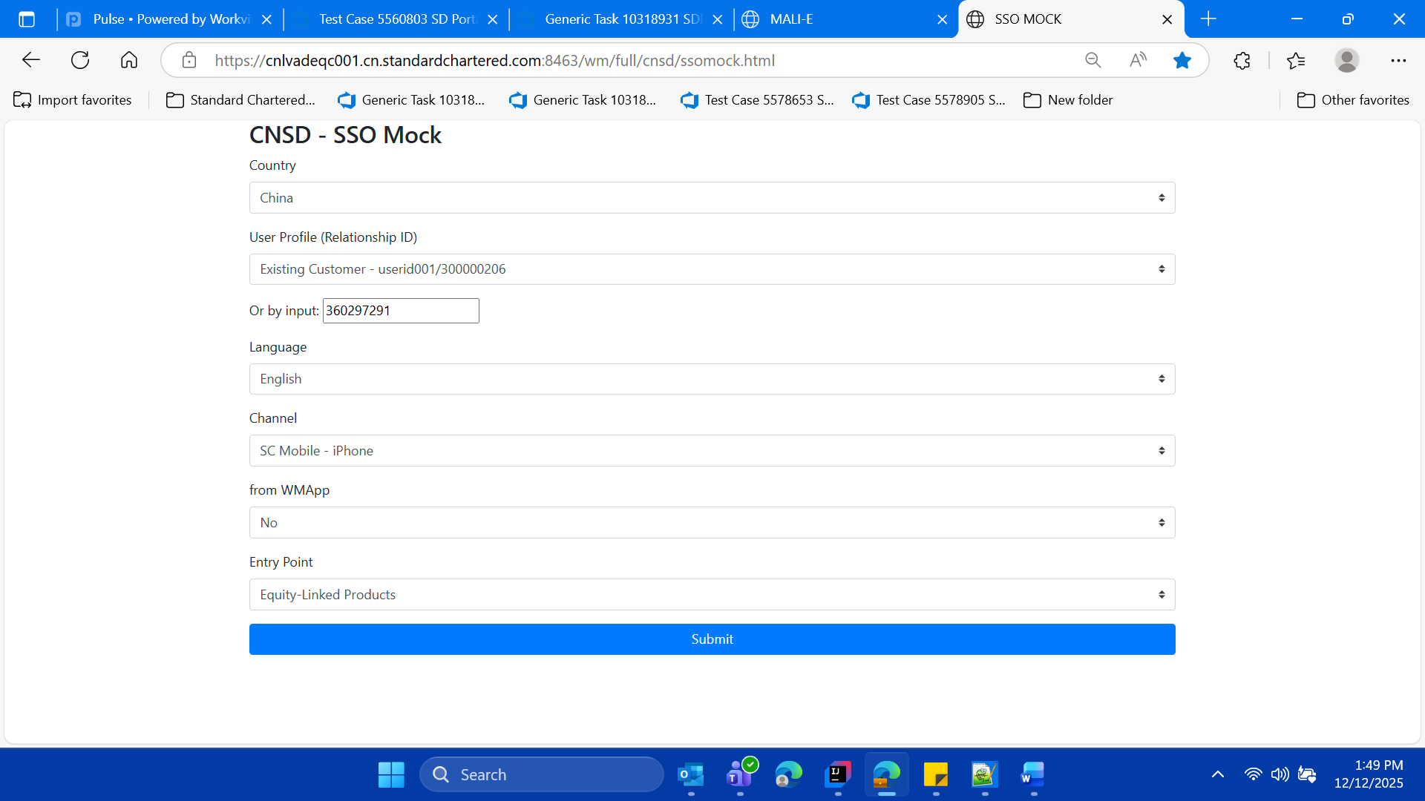

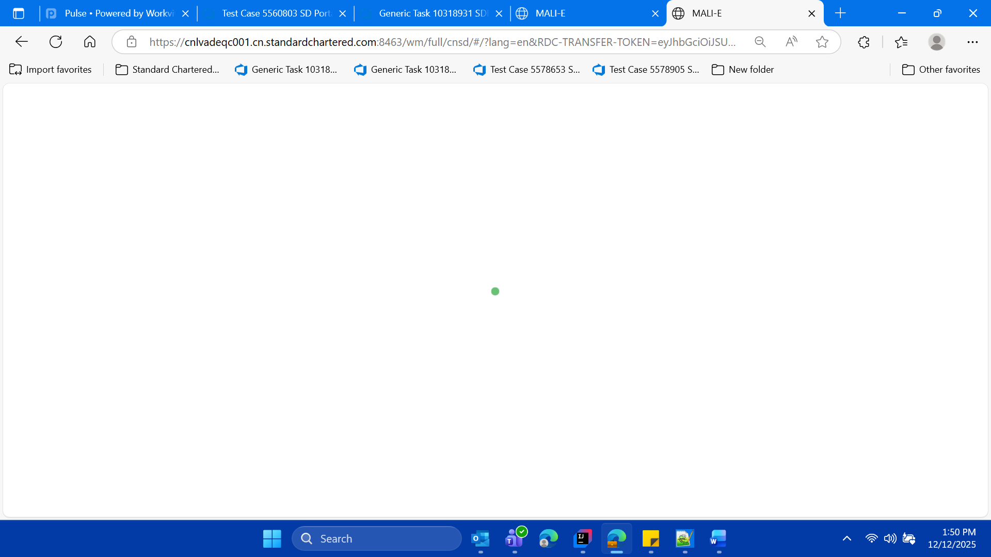

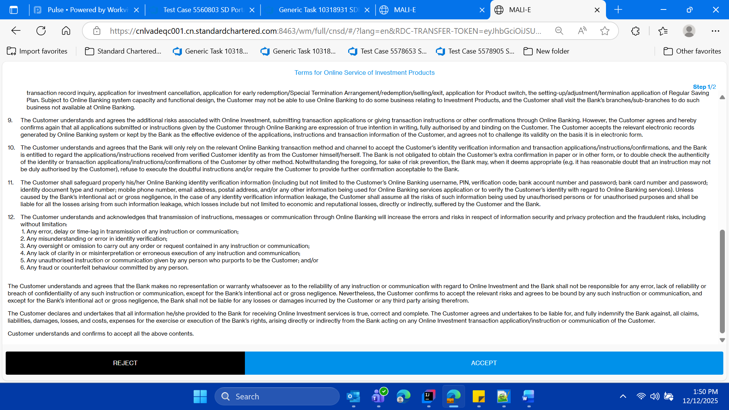

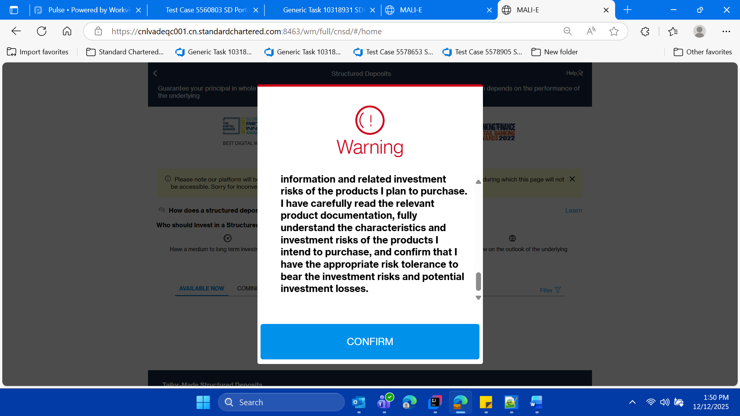

**Validate the landing page**

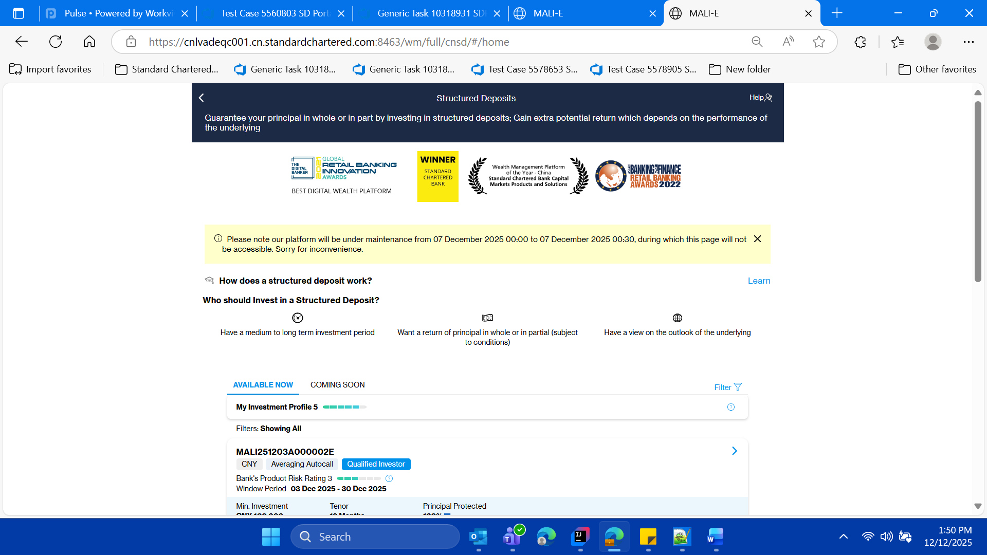

* **Log out from SSO MOCK and close the window.**

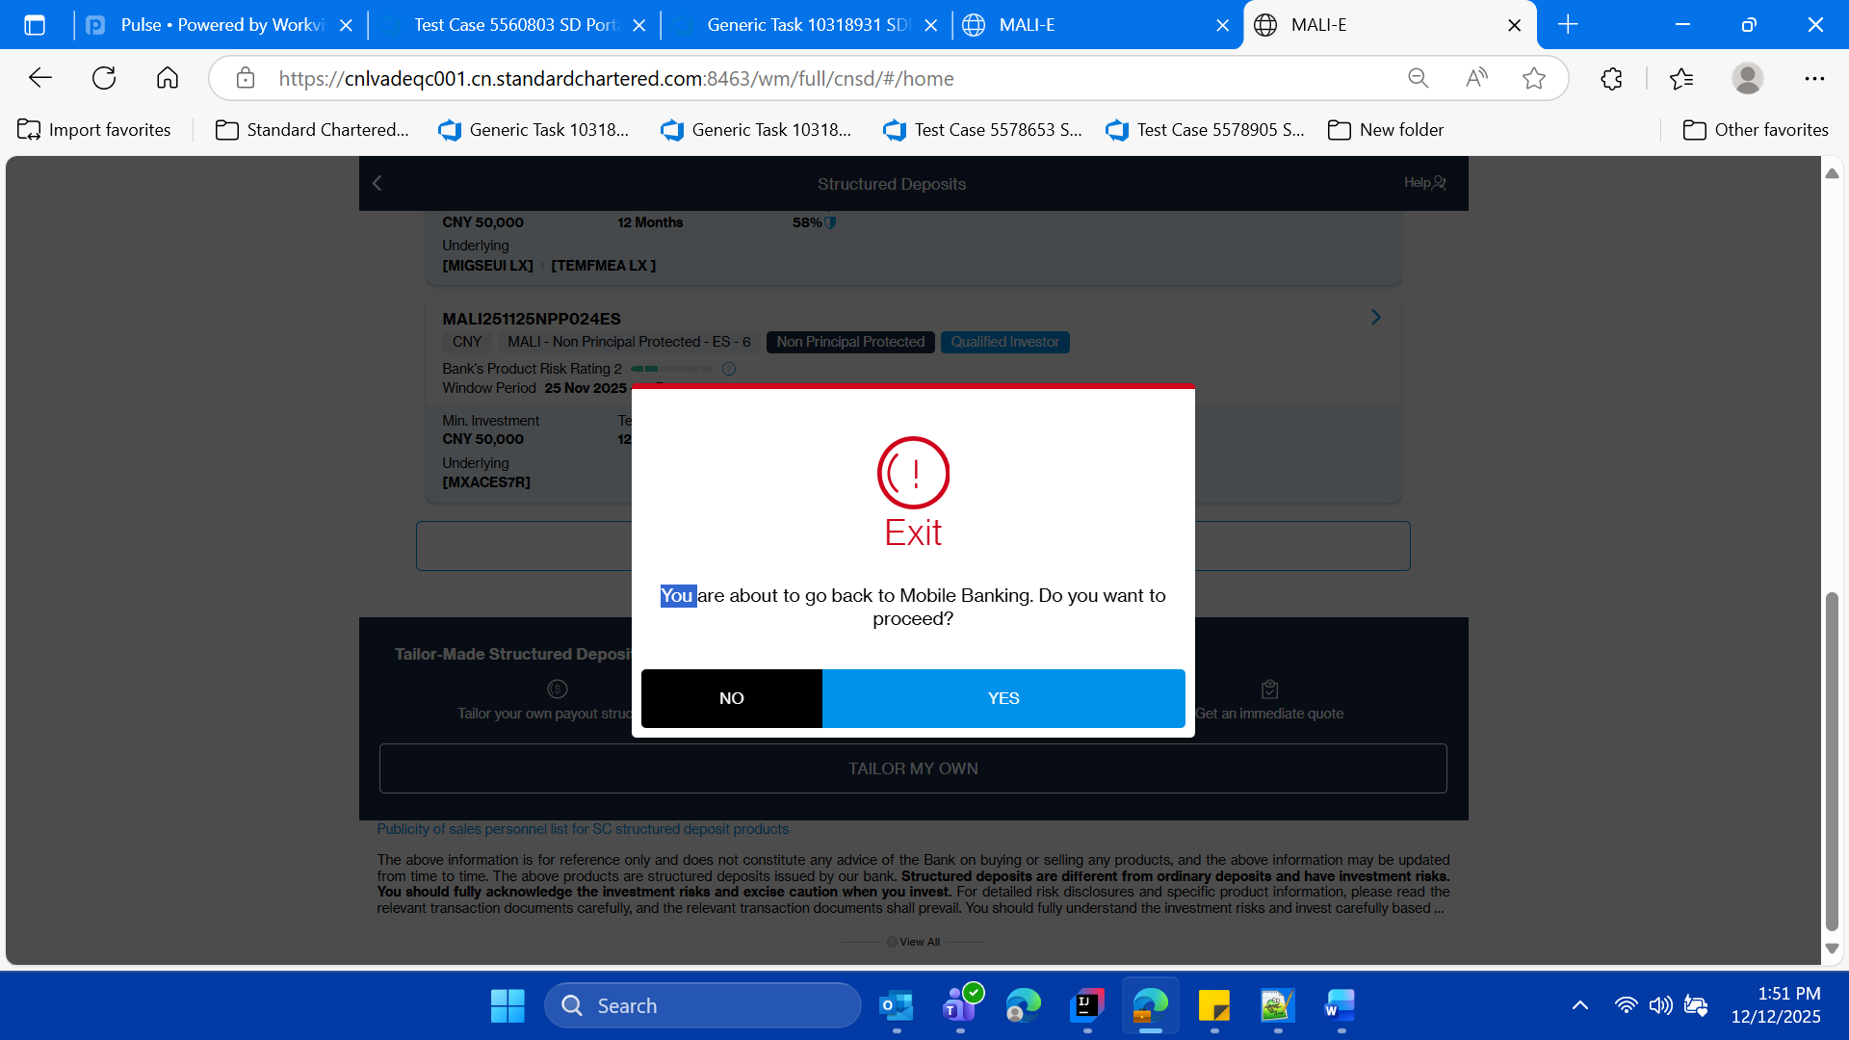

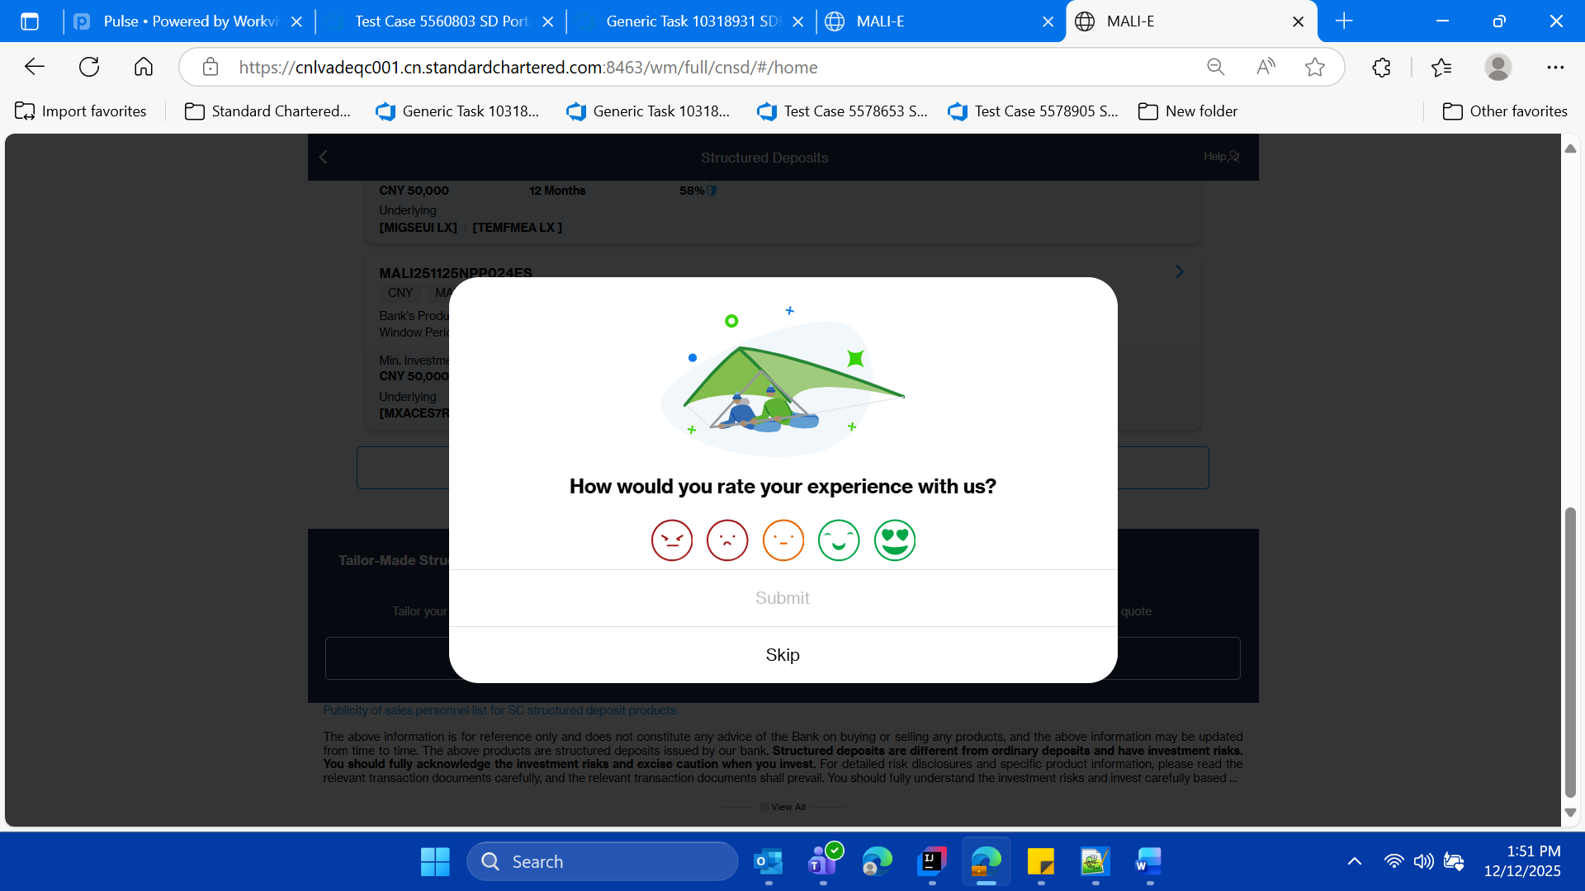

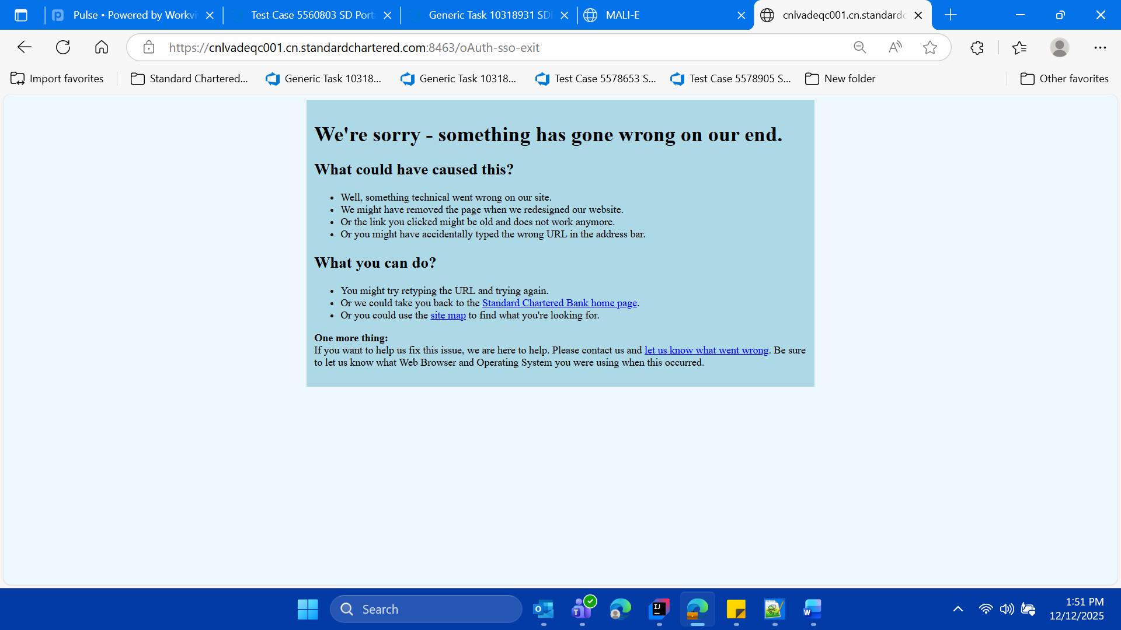

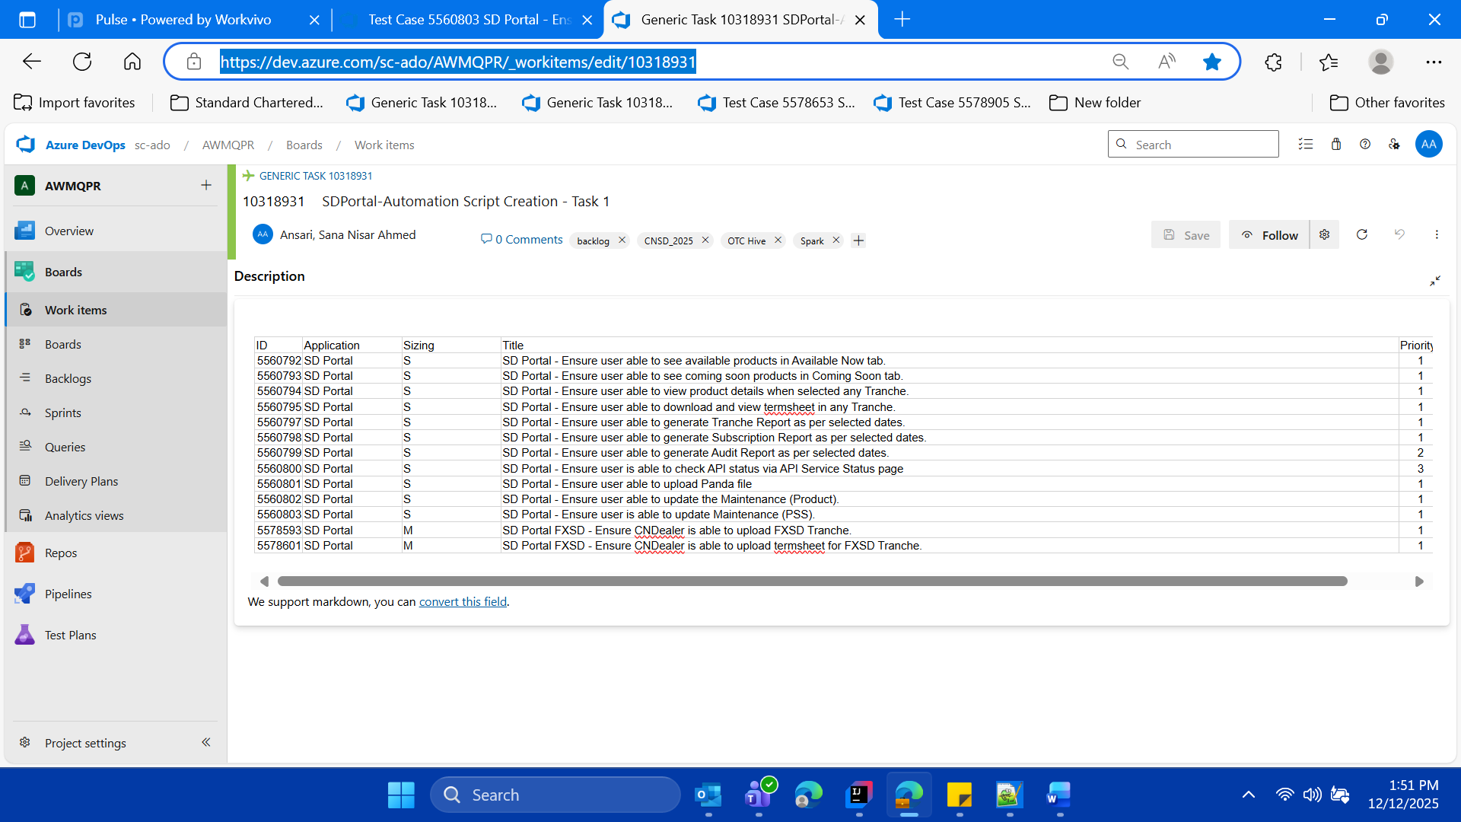

* **then logout of the SD Portal close the parent window of SD Portal**

